

# PROJECT: Shale-PIZZAAsss GROUP NO: 03 BATCH: T1.2004.M1

# 

# INTRODUCTION AND WEBSITE INSTALLATION:

- This document is created to guide users use the website – Shale-PIZZAAsss effectively. It is advisable that users should read this document before starting to use this website in reality.

- To run *Shale-PIZZAAsss* website, users need to do the following steps:

* + - 1. Download the file eProject SEM01_T1.2004.M1_Shale-PIZZAAsss_Group03.rar *(FPT Aptech HCM)* via this link:
      2. Extract the file rar: eProject SEM01_T1.2004.M1_Shale-PIZZAAsss_Group03.rar *(FPT Aptech HCM).*
      3. Open the folder eProject SEM01_T1.2004.M1_Shale-PIZZAAsss_Group03.
      4. Open the folder SourceCode
      5. Open *z1Home.html* file to start the website. Look at figure 1 for illustration

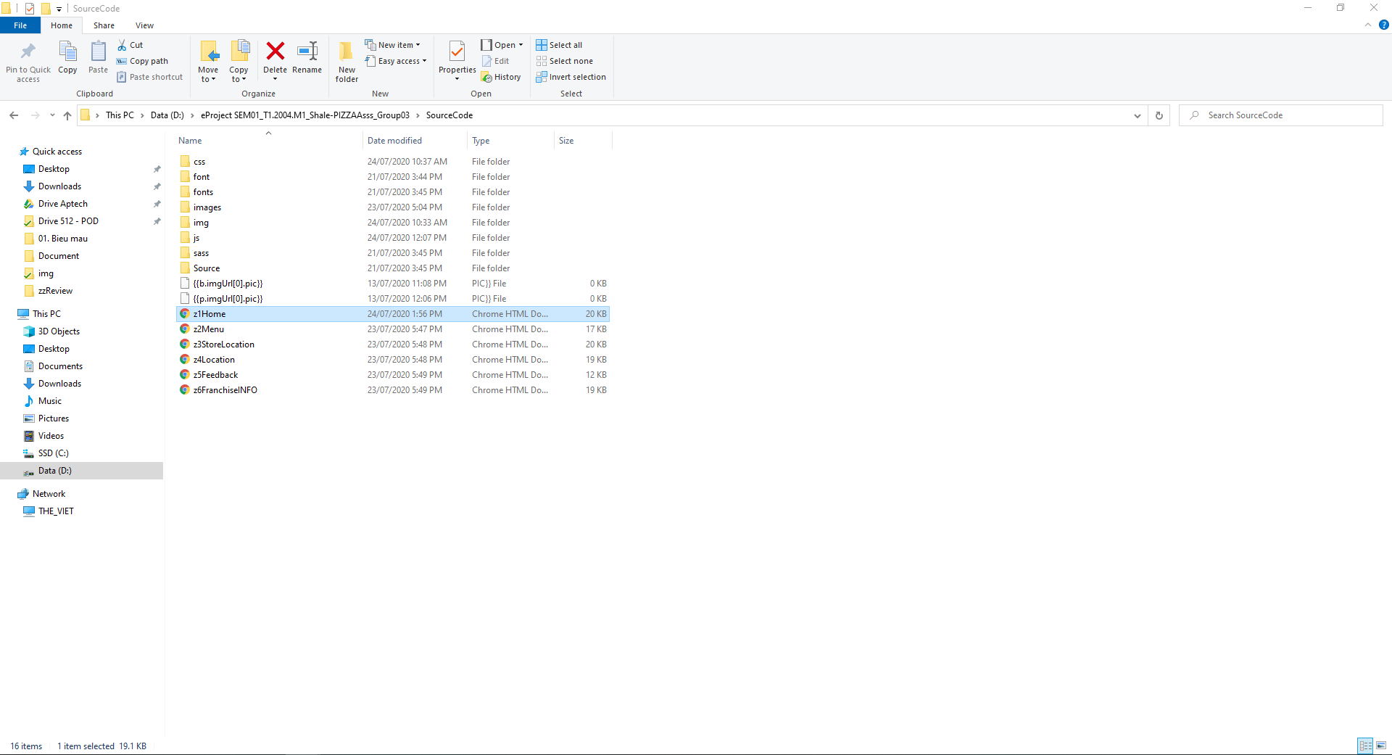

*Figure 1*

* + - 1. If done successfully, users will see the Homepage like figure 2 below



*Figure 2*

# HOME PAGE

- This site allows users to view information for the latest and hottest products.

- To view other products, users can click MENU or Product Name. For example, Figures 3 and 4 illustrate how to view other products



*Figure 3*

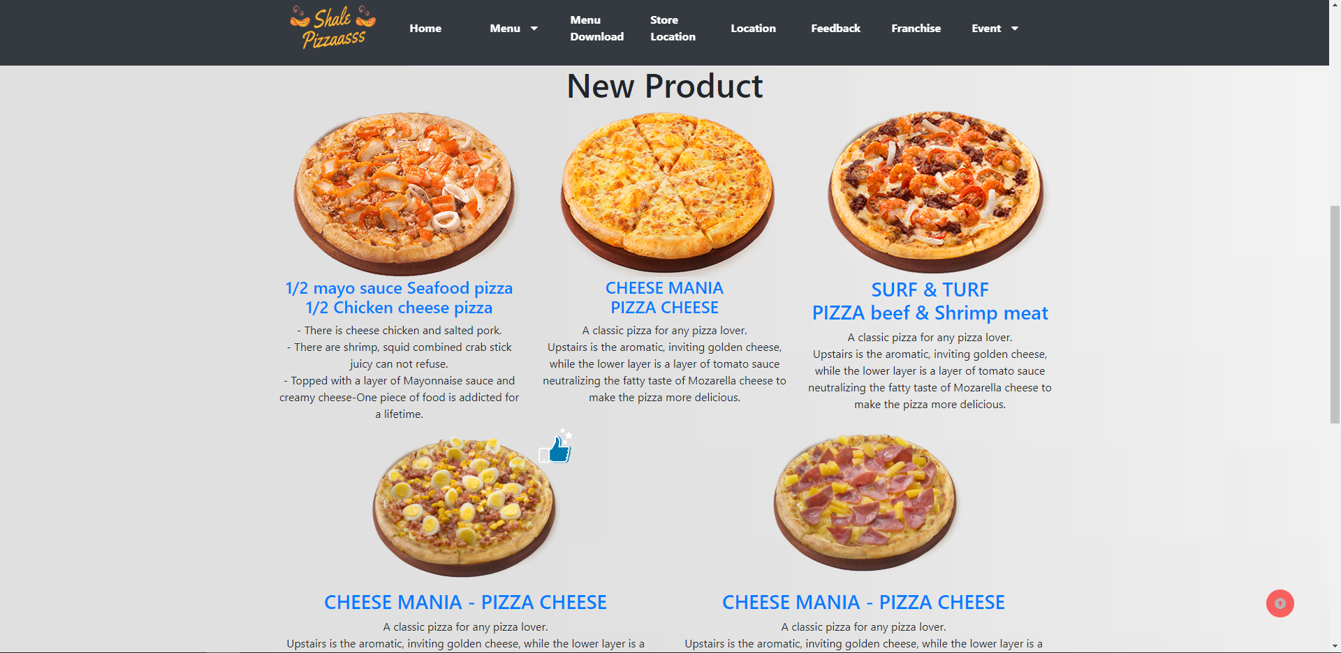

*Figure 4*

# MENU PAGE

- This webpage allows users to view the information for the products they’re need.

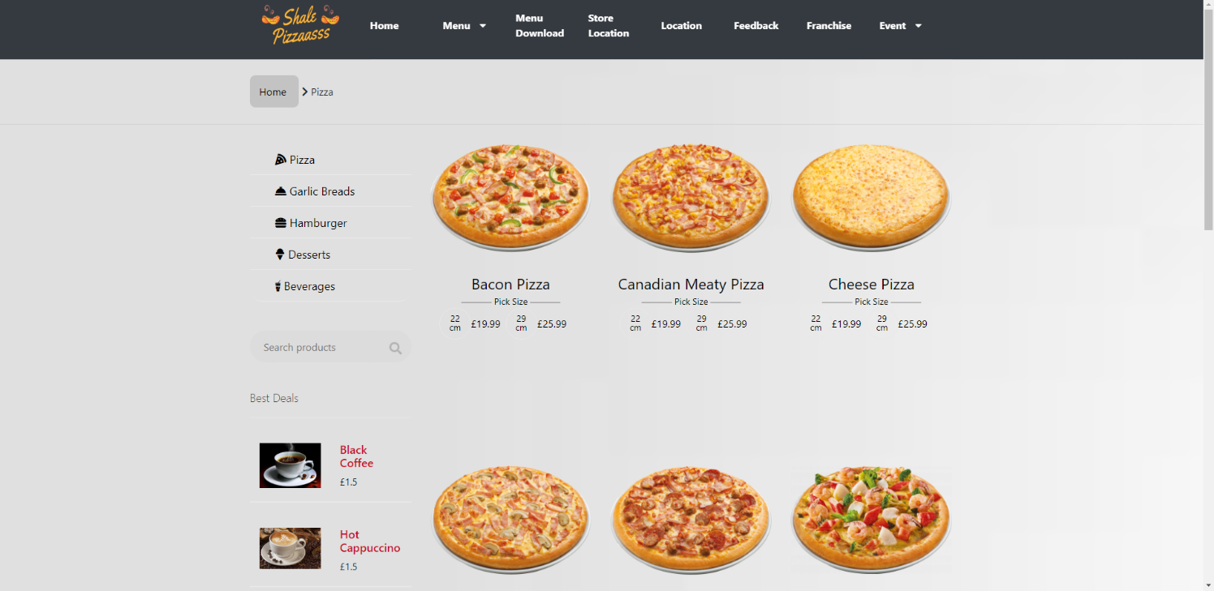- This component is the navigation bar for all websites in the Shale-PIZZAAsss website. To switch to other products, users simply need to click on a specific part. For example, Figure 5 below illustrates how to move from one Product page to another Product page.

*Figure 5*

*Figure 5*

# MENU DOWNLOAD

- Allow users to download menus.

*Figure 6*

# STORE LOCATION PAGE

- This website allows users to view a list of stores in each region and click on the address to view the map location. For example, Figures 7 and 8 below illustrate how to see the exact location of stores in each region.

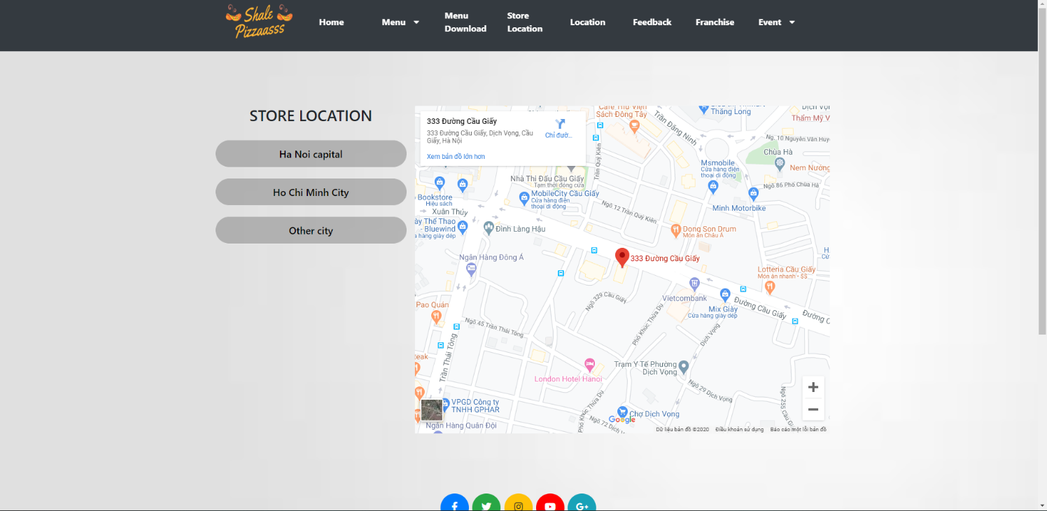

*Figure 7*

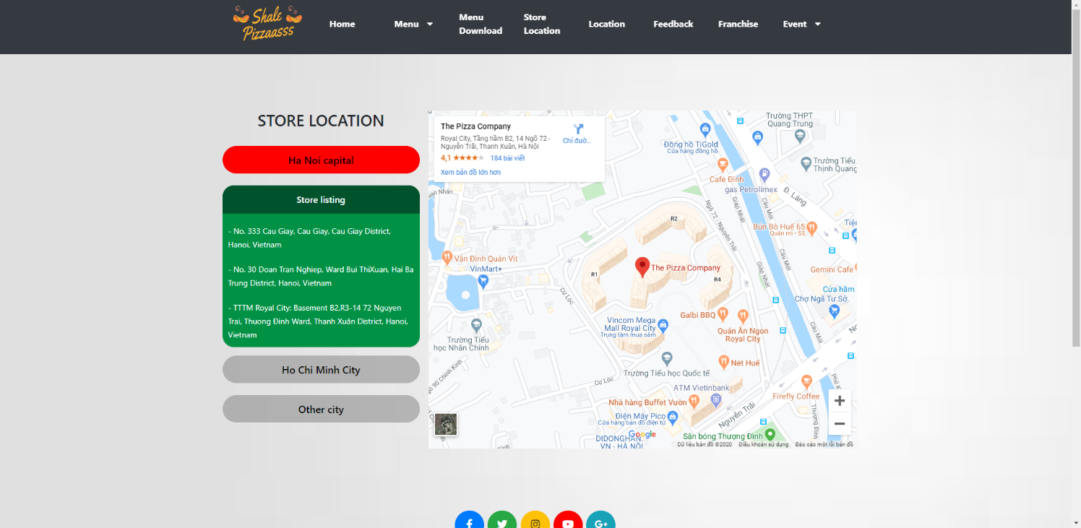

*Figure 8*

# LOCATION PAGE

- This site allows users to view our Address, Opening Hours and Contact Information. For example, Figures 9 and 10 below illustrate the information.

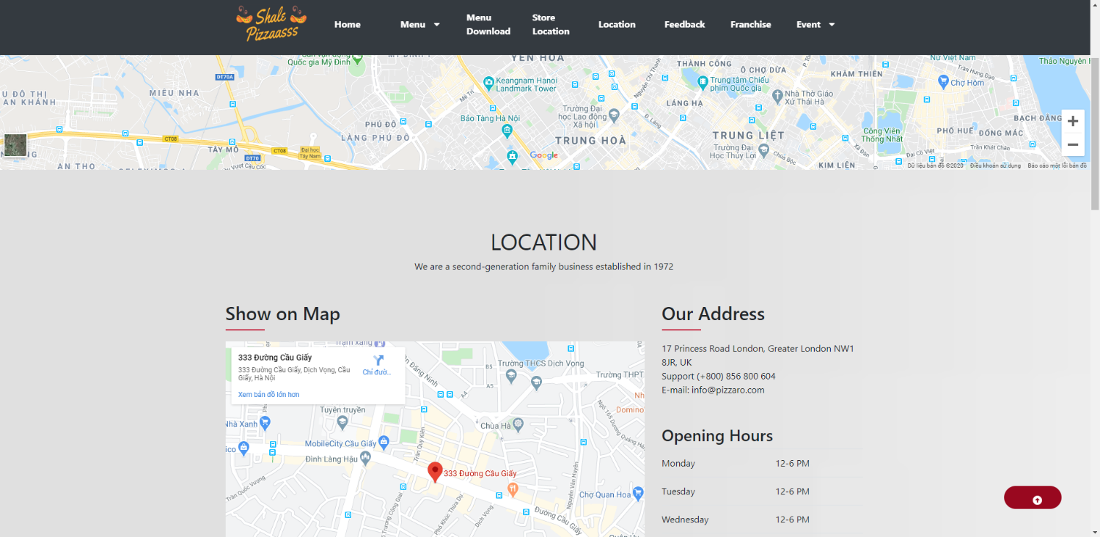

*Figure 9*

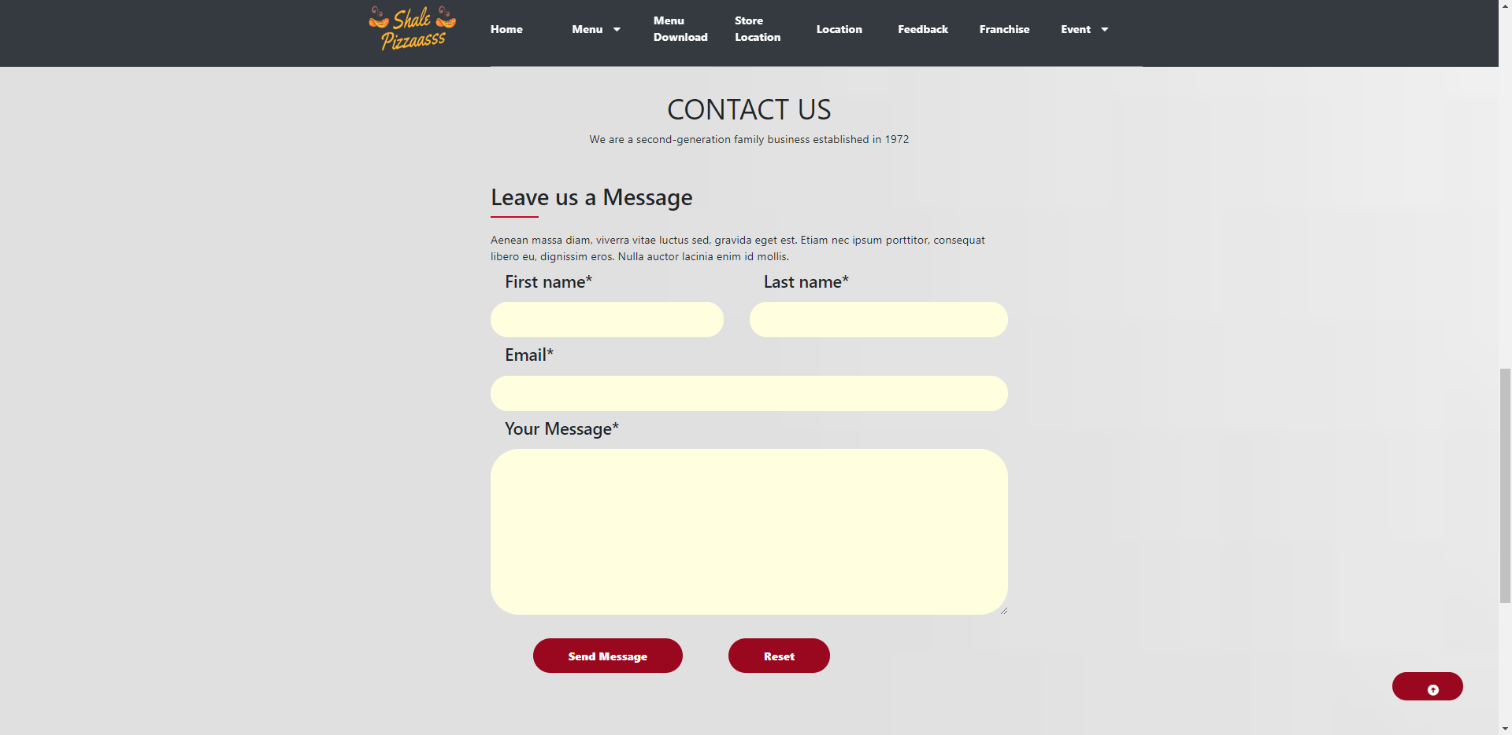

*Figure 10*

*Figure 10*

# FEEDBACK PAGE

- This site allows users to give feedback to the franchise area. For example, Figure 11 below illustrates the information.

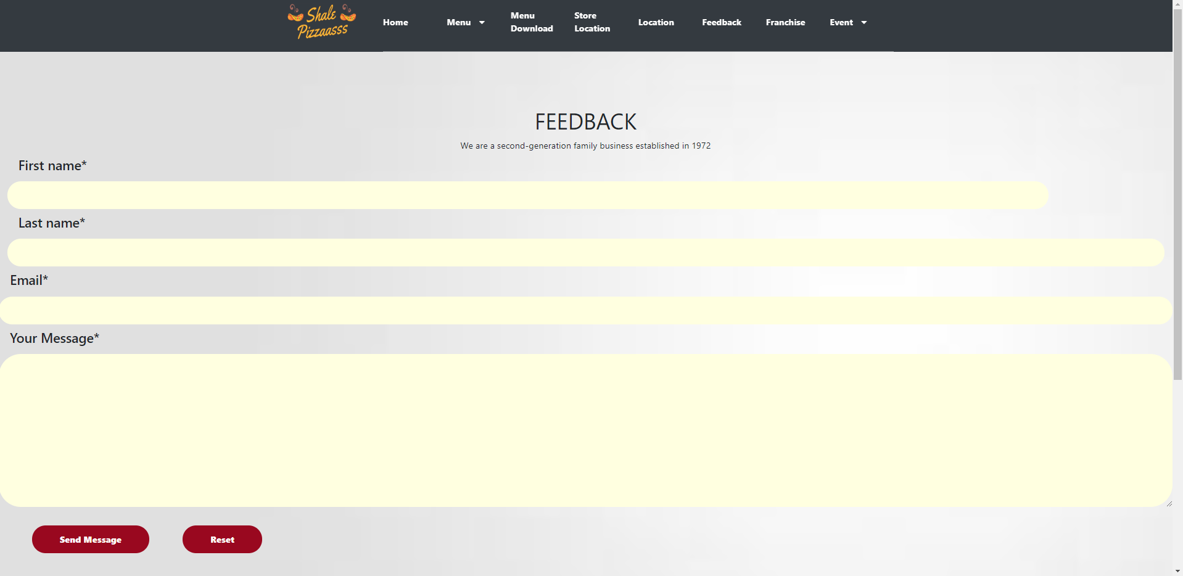

*Figure 11*

# FRANCHISE PAGE

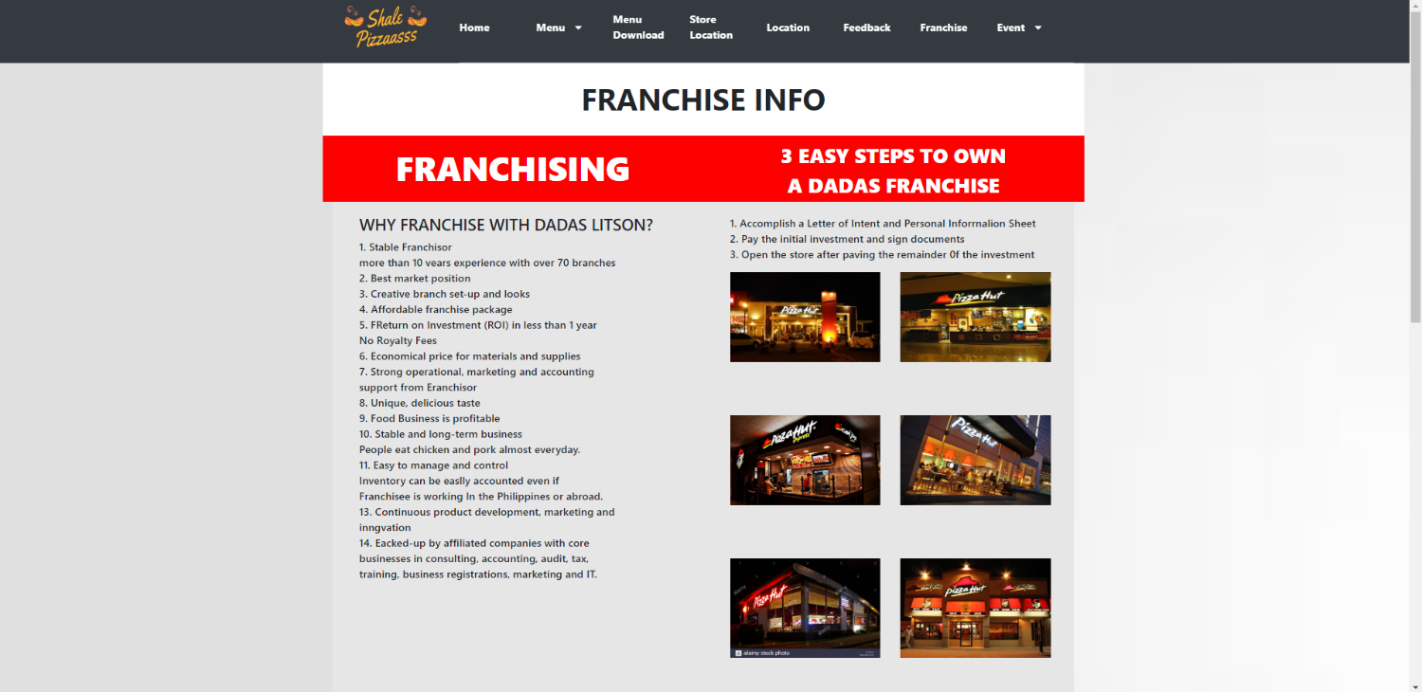- This site allows users to know franchise requirements. For example, Figure 12 below illustrates the information.

*Figure 12*